Forum documentation

Database structure

Tables

ForumUserAttributes
UserID | LastCount
int | int

Table contains information about the forum users.

UserID – User ID.
LastCount – Amount of threads, that the user select to view on the «My forums» page.

ForumsRead
ForumId | UserID | MarkReadAfter | LastActivity
int | int | int | datetime

Table contains information about the last post, that the user has read and the time of his last activity.

ForumId – Forum ID.
UserID – User ID.
MarkReadAfter – Post ID, indicating that all posts with fewer Ids are marked as read.
LastActivity – Last time of loading the threads list by the user.

PostsRead
UserID | PostId | HasRead
int | int | bit

Table contains information about the post, which has been read by the users.

PostId – Post ID.
UserID – User ID.
HasRead – Whether or not the post marked as read?

ThreadTrackings
ThreadID | UserID
int | int

Table contains information about the users tracking the threads.

ThreadID – Thread ID.
UserID – User ID.

Posts
PostID | ThreadID | ParentID | Subject | PostDate | ForumID
int | int | int | nvarchar | datetime | int

UserID | ThreadDate | TotalViews | IsLocked | IsPinned | IsPostPinned | PinnedDate | Body
int | datetime | int | bit | bit | bit | datetime | ntext

Table contains all posts.

PostID – Unique post ID.
ThreadID – ID of the first post in the current post’s thread.
ParentID – ID of the parent post. Current post is a reply for parent one. It’s equal to 0, if it’s the first post in a thread.
Subject – Post’s subject.
PostDate – When was the post added to the forum.
ForumID - ID of the post’s forum.
UserID – Post author ID.
ThreadDate - When the first post of the current post’s thread was added to the forum.
TotalViews – Total amount of views of the post.
IsLocked – Whether or not the post locked.
IsPinned – Whether or not the post pinned.
IsPostPinned- Whether or not the post pinned inside the thread.
PinnedDate - When the post was pinned.
Body – Post’s body.

Forums

ForumID | Name | Description | DateCreated | TotalPosts | TotalThreads
int | nvarchar | nvarchar | datetime | int | int

MostRecentPostID | MostRecentThreadID | MostRecentPostDate | MostRecentPostAuthor  ID
int | int | datetime | int

Table contains all forums.

ForumID - Unique forum ID.
Name – Forum caption.
Description – Forum description.
DateCreated – The date, when the forum was created.
TotalPosts – total amount of posts in the forum.
MostRecentPostID – ID of the most resent post in the forum.
MostRecentThreadID - ID of the most resent thread in the forum.
MostRecentPostDate – Date of the most resent post in the forum.
MostRecentPostAuthor – Domain name of the most resent post’s author in the forum.

Stored Procedures
forums_GetTopicsUserMostRecentlyParticipatedIn - Returns a collection of threads that the user has recently participated in.
forums_GetTopicsUserIsTracking - Returns a collection of threads that the user is tracking
forums_MarkPostAsRead - Flags a post a 'read' in the database
forums_GetTotalPostsForThread - Returns the total number of posts in a given thread. This call is used mainly by paging when viewing posts.
forums_GetTotalPinnedPostsForThread - Returns the total number of pinned posts in a given thread. This call is used mainly by paging when viewing posts.
forums_TopicCountForForum - Returns the total number of threads in a given forum
forums_MarkAllThreadsRead - Marks all threads from Forum ID and below as read
forums_GetAllTopicsPaged - Returns all threads
forums_IsUserTrackingPost - Is the user tracking this thread?
forums_GetTotalPostCount - Returns count of all posts in system.
forums_GetPostInfo - Get basic information about a single post.
forums_ReverseTrackingOption - Reverses a particular user's email thread tracking options for the thread that contains the post specified by PostID.
forums_GetThread - Returns a collection of Posts that make up a particular thread.
forums_GetThreadByPostIDPaged - Returns a collection of Posts that make up a particular thread with paging
forums_IsDuplicatePost – Method checks whether the post we are trying to insert is duplicate.
forums_AddPost - Adds a new Post.
forums_UpdatePost - Updates a post.
forums_DeleteModeratedPost - This method deletes a particular post and all of its replies.
forums_GetForumByThreadID - Returns information about a particular forum that contains a particular thread.
forums_GetForumInfo - Returns a Forum object with information on a particular forum.
forums_GetForumByPostID - Returns information about a particular forum that contains a particular post.
forums_GetAllForums - Returns a list of all Forums.
forums_DeleteForum - Deletes a forum and all of its posts.
forums_AddForum - Adds a new forum.
forums_UpdateForum - Updates an existing forum.
forums_GetTotalNumberOfForums - Returns the total number of forums.
forums_SetLastCount – Stores the number of threads the user participated in.
forums_GetSearchResults - Performs a search, returning appropriate posts.
forums_CanEditPost - Determines if a user can edit a particular post.
forums_MovePost - Moves a post from one Forum to another.
Maintenance_CleanForumsRead – Removes unnecessary values from ForumsRead table.
Statistics_ResetForumStatistics, Statistics_UpdateForumStatistics – Used to maintain forum statistics.

Business objects

class AspNetForums.Components.User
This class defines the properties of a forum user.

Properties

String Username – The User ID, that uniquely identifies each user
String DisplayName - Returns the user's name, tha is displayed to users.
String Password - Returns the user's password.
int TotalPosts - Total posts by this user.
bool IsApproved - Specifies whether a user is Approved or not. Non-approved users cannot log into the system and, therefore, cannot post messages.
bool IsAdministrator - Specifies if a user is an administrator or not.
bool IsModerator - Specifies if a user is a maderator or not.

class AspNetForums.Components.UserCollection

Constructors

public UserCollection()
public UserCollection(ICollection c)

class AspNetForums. Users
This class contains methods used work with forum user.

Methods

public static User GetUserInfo(String username, bool updateIsOnline) – Returns information about current user.
public static UserCollection GetAllUsers(int pageIndex, int pageSize) - Returns all the users currently in the system.
public static User GetLoggedOnUser() - Short-cut for getting back a user instance
public static void UpdateUserInfoFromAdminPage(User user) - Updates a user's system-level information.
public static bool ValidUser(User user) - Determines if the user is a valid user.
User - The user to check. Note that the Username and Password properties of the User object must be set.
public static int TotalNumberOfUserAccounts() - Calculates and returns the total number of user accounts.

class AspNetForums.Components.Transforms
Contains methods used to transform contents of strings based on settings of forums

Methods

string TransformString(string stringToTransform) - Method used to transform contents of string based on settings of forums
private static string EnsureSafeAnchors(string stringToTransform) - Ensure we have safe anchors
private static string PerformUserTransforms(string stringToTransform, ArrayList userDefinedTransforms) - Performs the user defined transforms
private static ArrayList LoadUserDefinedTransforms() - Returns a array list containing transforms that the user defined. Usually in transforms.txt

class AspNetForums.Components.Post
This class defines the properties of a forum post.

Properties

int PostID - Specifies the ID of the Post, the unique identifier.
bool IsLocked - Whether or not this post allows replies
bool HasRead - Whether or not this post allows replies
bool IsAnnouncement - If post is locked and post date > 2 years
bool IsPinnedPost - Whether or not the post pinned inside the thread.
int Views - Total number of views for a given post
int ThreadID - Indicates what thread the Post belongs to.
int ParentID - Specifies the thread's parent ID. (That is, the PostID of the replied-to post.)
int ForumID - Specifies the ID of the Forumt the post belongs to.
int Replies - Specifies how many replies have been made to this post.
String Username - Returns the Username of the user who made the post.
String ForumName - Returns the name of the Forum that the Post belongs to.
String Subject - Returns the subject of the post.
String Body - Returns the body of the post.
DateTime PostDate - Specifies the date/time the post was made, relative to the database's timezone.
ThreadDate - Specifies the date/time of the most recent post in the thread.

class AspNetForums.Components.PostCollection

Constructors

public PostCollection()
public PostCollection(ICollection c)

Properties

int TotalRecordCount – Total records in the collection.

class AspNetForums.Components.Thread : Post
This class defines the properties of a forum thread.

Properties

bool IsPinned - If post is post date > DateTime.Now
bool IsPopular - If thread has activity in the last 2 days and > 20 replies
DateTime PinnedDate - Controls the sort order of posts by date
string MostRecentPostAuthor - The author of the most recent post in the thread.
int MostRecentPostID - The post id of the most recent post in the thread.

class AspNetForums.Components.ThreadCollection

Constructors

public ThreadCollection()
public ThreadCollection(ICollection c)

Properties

int TotalRecordCount – Total records in the collection.

class AspNetForums.Components.Forum
This class defines the properties of a single forum.

Properties

virtual bool IsAnnouncement - If post is locked and post date > 2 years
int ForumID - Specifies the unique identifier for the each forum.
DateTime LastUserActivity – Indicates last user activity
int TotalPosts - Indicates how many total posts the forum has received.
DateTime MostRecentPostDate - Specifies the date/time of the most recent post to the forum.
int MostRecentPostId - Specifies the most recent post to the forum.
int MostRecentThreadId - Specifies the most recent thread id to the forum.
String MostRecentPostAuthorID - Specifies the author of the most recent post to the forum.
String MostRecentPostAuthorDisplayName - Specifies the display name for the author of the most recent post to the forum.
int TotalThreads - Indicates how many total threads are in the forum. A thread is a top-level post.
String Name - Specifies the name of the forum.
String Description - Specifies the description of the forum.
DateTime DateCreated - Returns the date/time the forum was created.

class AspNetForums.Components.ForumCollection

Constructors

public ForumCollection()
public ForumCollection(ICollection c)

class AspNetForums.Posts
This class contains methods used work with forum posts.

Methods

public static Post GetPost(int postID, string username) - Returns information about a particular post.
public static bool IsUserTrackingThread(int threadID, String username) - Returns a boolean to indicate whether the user is tracking the thread.
public static void ReverseThreadTrackingOptions(String username, int postID) - This method reverses a user's thread tracking options for the thread containing a particular Post.
public static void MarkPostAsRead(int postID, string username) - Given a post id, marks it as read in the database for a user.
public static PostCollection GetThreadByPostID(int postID, int currentPageIndex, int defaultPageSize) - This method returns a listing of the messages in a given thread using paging.
public static PostCollection GetThread(int threadID) - This method returns a listing of the messages in a given thread.
public static int GetTotalPostCount() - Returns the total count of all posts in the system
public static Post AddPost(Post postToAdd) - This method Adds a new post and returns a Post object containing information about the newly added post.
public static void UpdatePost(Post post, bool ChangePin) - This method updates a post (called from the admin/moderator editing the post).
public static String PostSubjectRawToFormatted(String rawMessageSubject) - Converts the subject line from raw text to the proper display.

class AspNetForums.Forums
This class contains methods used work with forums.

Methods

public static void MarkAllThreadsRead(int forumID, string username) - Marks all threads in the current forum as read
public static ForumCollection GetAllForums() - Returns all of the active forums in the database.
public ListItemCollection ForumListItemCollection(string username, ForumListStyle listStyle) - A listing of forums and forum groups.
public ListItemCollection ForumListItemCollection(string username, ForumListStyle listStyle, ListItemCollection listItems) - A listing of forums.
public static ForumCollection GetAllForums(string username) - Returns all of the forums in the database.
public static Forum GetForumInfo(int forumID) - Returns information on a particular forum.
public static int GetTotalThreadsInForum(int forumID, DateTime maxDateTime, DateTime minDateTime) - Used in paging to return a count of the forums based on the query
public static Forum GetForumInfoByPostID(int PostID) - Returns information about the forum that a particular post exists in.
public static Forum GetForumInfoByThreadID(int ThreadID) - Returns information about the forum that a particular thread exists in.
public static void DeleteForum(int forumID) - Deletes a forum and all of the posts in the forum.
public static void AddForum(Forum forum) - Creates a new forum.
public static void UpdateForum(Forum forum) - Updates a particular forum.
public static String ForumDescriptionFormattedToRaw(String Description) - Converts the forum description from formatted text to raw text.

class AspNetForums.Threads
This class contains methods used work with threads.

public static ThreadCollection GetAllThreads(int forumID, string username, bool unreadThreadsOnly) - Returns a collection of threads based on the properties specified.
public static ThreadCollection GetThreadsUserMostRecentlyParticipatedIn(string username, int count) - Returns threads that the user has recently participated in.
public static ThreadCollection GetThreadsUserIsTracking(string username) - Returns threads that the user has tracking enabled for.
public static int GetTotalPostsForThread(int postID) - Total number of posts in a given thread.
public static int GetTotalPinnedPostsForThread(int postID) - Total number of pinned posts in a given thread.

User Interface

Main page

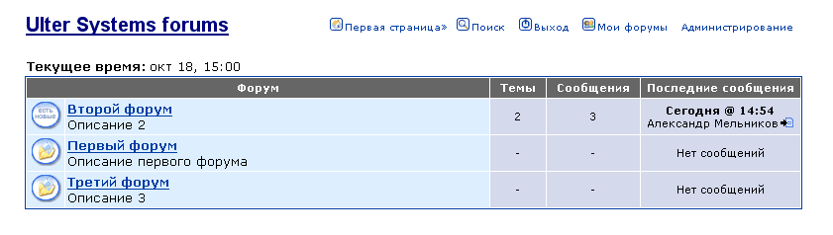
It contains the following controls:
NavigationMenu – it is situated on all forum pages. It contains Forums logo and several links to other pages. The “Administrarion” link is shown for administrators only.

ForumRepeater – it contains a header and a list of all forums. For each forum it shows icon, indicating whether there is a new posts in the forum from the time of last user visit, its name and description, number of threads and posts and brief information about the last post in it.

Show forum page

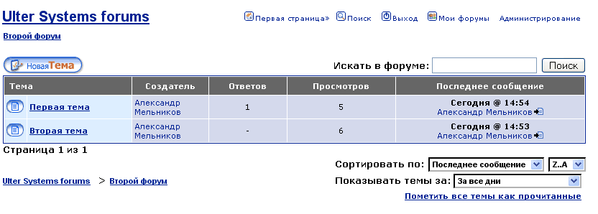
It contains:
ThreadView – it shows all threads in the specified forum, including the icon, showing whether it has new posts from the time of the users last visit, threads caption, the author name, and the amount of replies, the amount of views, and brief information about the last post in it. Also this control contains the “New Thread” button, the form to search in the forum, and dropdown boxes to select the sort order and time of the threads that the user wishes to watch. Also there is a link to mark all threads as read and links to the parent page. There is also a links to other pages, if the pages more than one.

Show post page
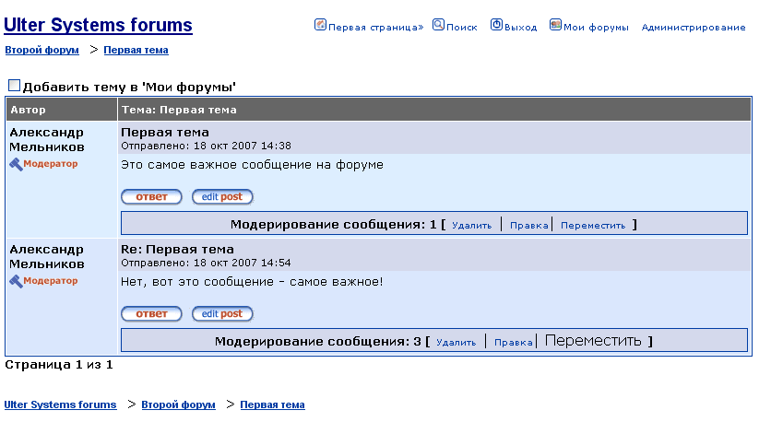
It contains a check box that allows you to add the thread to the my forums page, links to the parents pages, and a list of posts.
Each post contains the author name, caption, posts body, its date and time and the reply button (it is shown if post isn’t locked). If the user is the author of the post, there is also the edit post button available.
If the user is a forum administrator, a special moderation menu is available. It includes the delete button, the edit button and the move button. There is also a links to other pages, if the pages more than one.

Create and edit post page
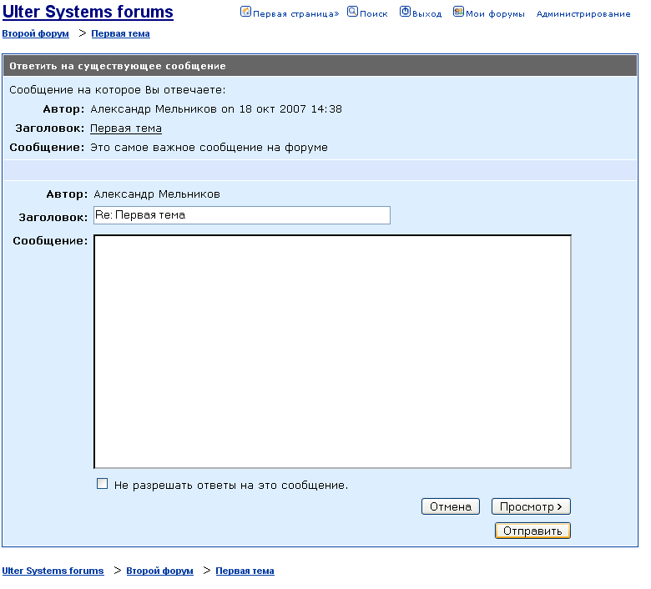
It contains the user name, text boxes for caption and for posts body, checkbox “lock the post”, buttons to cancel to preview and to send a post.
If the control in the reply mode, there is also a brief information about the parent post.
If it is the new first post in the thread, it is possible for administrators to mark the post as announcement, placed on the top of a forum.

Search page
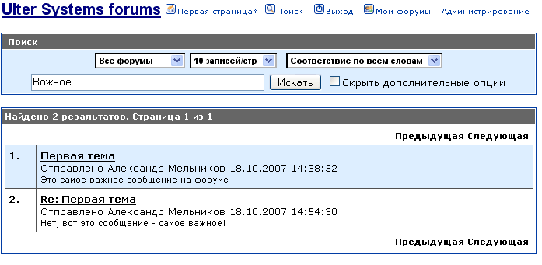
It contains controls that allow selecting the search area and other search criteria. They are shown only if “hide additional options” checkbox is not set.
After pressing the search button, the search results are shown under the search options panel. Each search results contain its number, post caption, author username, post date and time and part of posts body.
Also there is a links to the previous and next pages if there are more than one search results pages.

My Forums page
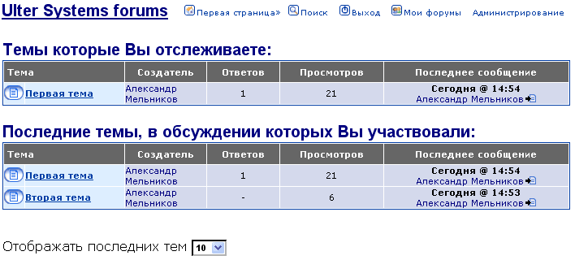
It contains a list of threads, that user selects to track, and threads where the user participated in.
And also there is a dropdown box to select the amount of last threads to show.

Move post page
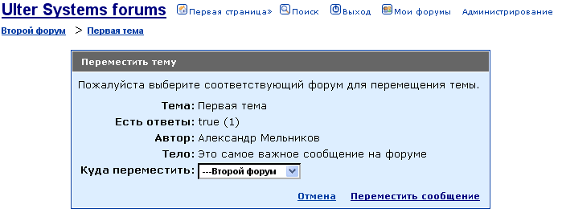 It contains brief information about moving thread a list of forums to move to.

Main administration page
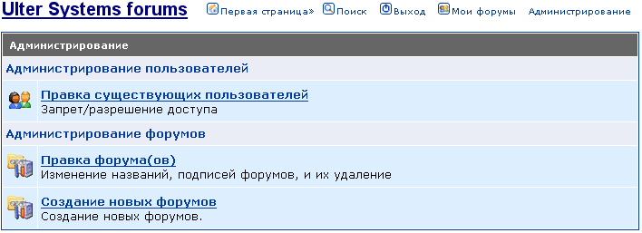 It contains links to the administration tools, such as users’ administration and forums administration.

Create and edit forum

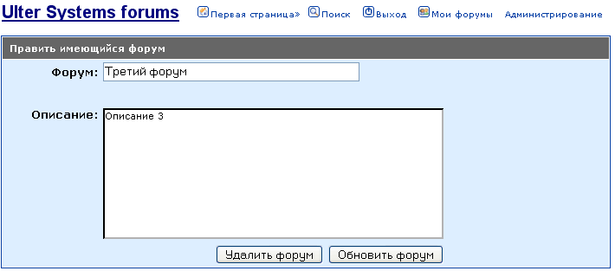 It contains text boxes for forum caption and description, buttons to save information and to delete the forum (button available only edit mode).

Users administration page
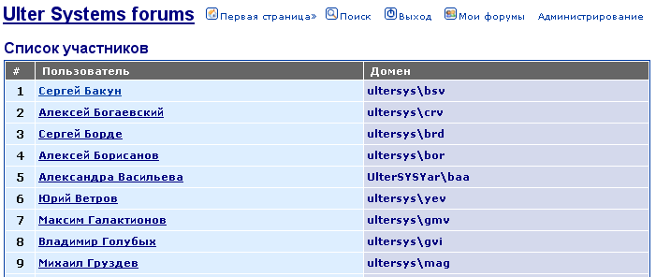
It contains the list of users and their domains. Administrators can the select the user to change his options.

User options page
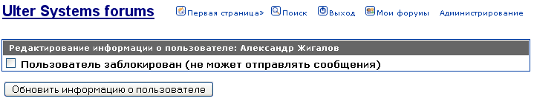
It contains checkbox to block the user and a button to submit information.

